Solid Fuel Appliance Questionnaire  (For Wood and Pellet Stoves – One Questionnaire Per Unit) |   Intact Insurance Company

Insured Name: | Policy Number:
Address:
Brokers Name:

Equipment and Installation Details
1. Type of appliance:
Stove Space Heater Fireplace Fireplace with Insert Other including Pellet Stove
2. Does the appliance have a Certification Label?
No Yes Don’t Know (D/K)
3. If Yes, indicate Certification Agency:
U.L.C. (Underwriters’ Laboratories Canada) C.S.A. (Canadian Standards Association)
WH (Warnock Hersey Professional Services) Other (specify):
4. Name of Manufacturer: |  | Model No: | Age of appliance:
5. Is unit installed in accordance with manufacturer’s specifications?
No Yes D/K
6. List clearance requirement printed on approval plate or attach copy of instructions:

Use, Fuel Storage, Consumption and Ash Disposal
1. Is appliance used for:
Primary Heating (more than 50% of heat)? Secondary Heating (less than 50% of heat)?
Space Heating (heating of individual room)? Recreational Purposes (for enjoyment and pleasure)?
2. What is the primary heat source if another appliance?
3. How far is the wood, pellets or solid fuel stored from the unit?
feet metre
4. How many cords or wood, tons of pellets or other solid fuel used per year?
5. Has there been a previous chimney fire?
No Yes
If yes, in the Remark Section, indicate date, extent of damage, details of repairs, whether chimney was inspected after repairs and name of inspection company or technician.
For wood or coal appliances — answer questions 6a. and 6b.:
6a. Are ashes stored in a metal container? | 6b. Is the container stored outdoors?
No Yes | No Yes

Chimney Details and Maintenance

Wood and Coal Appliances (Items 1 to 7):
1. Type of Chimney:
Masonry with steel liner Bricks and mortar with flue tile lining
Blocks and mortar with flue tile lining Factory built double walled metal chimney
None D/K
Other (specify):
2. Chimney certified or labeled by:
CSA ULC WH Not Certified/labeled D/K
Other (specify):
3. Does the unit share a chimney flue with any other heating unit?
No Yes
3a. If yes, describe the other unit and specify type of fuel used:
Description:
Fuel: Gas Oil Solid Fuel
3b. Is solid fuel appliance vented below, above or same level as the other unit?
Below Above Same Level N/A
4. Chimney is installed:
Inside Building Outside Building
5. How often chimney is cleaned?
6. Date of last cleaning (year/month):
7. Who does the cleaning?
Homeowner Qualified Chimney Cleaner

Pellet Stoves (Items 8 to 9):
8. Is there a battery back up or alternate source of power?
No Yes
9. How is pellet stove vented?
Above Roof Through Side Wall with Riser Horizontally Through Side Wall (No Riser)

Flue Pipe (Complete for Wood or Coal Burning Appliance)
1. Type of flue pipe:
Single lined Double lined Black DC2100
Prefab Section Galvanized Stainless Steel Other
2. Flue Pipe certified or labeled by:
CSA ULC WH Not Certified or Labeled D/K
Other (specify):

Installation
1. Was the heating unit installed by a heating contractor or WETT certified technician?
D/K No Heating Contractor WETT Certified Technician
If Heating Contractor -- Name of Company:
If WETT Certified Technician – WETT Certification #:
2. Was the chimney installed by a heating or masonry contractor?
D/K No Yes
If yes – Name of Company:
3. Does the stovepipe pass through a concealed space?
No Yes
4. Is protective shielding used around heating unit? If so, describe (material used, clearances, etc):
5. Has installation including chimney been inspected and approved by fire department or building code inspector?
No Yes D/K

Installation Diagram
Provide installation and construction details of the heating appliance as detailed in the diagram. If your unit is installed differently provide a diagram of your own. A photo is required.

(b)

Construction of:  back wall (a)  ceiling (b)  Is there a ULC/CSA approved thimble where the pipe passes through wall or ceiling (c)?  No Yes  Total length of stovepipe (d)  in cm  Shortest distance of unit to  back wall (e) in cm  Distance of unit to floor ( f)  in cm  Distance of side of unit to end of pad (g) in cm  Distance of front of unit to end of pad (h) in cm | 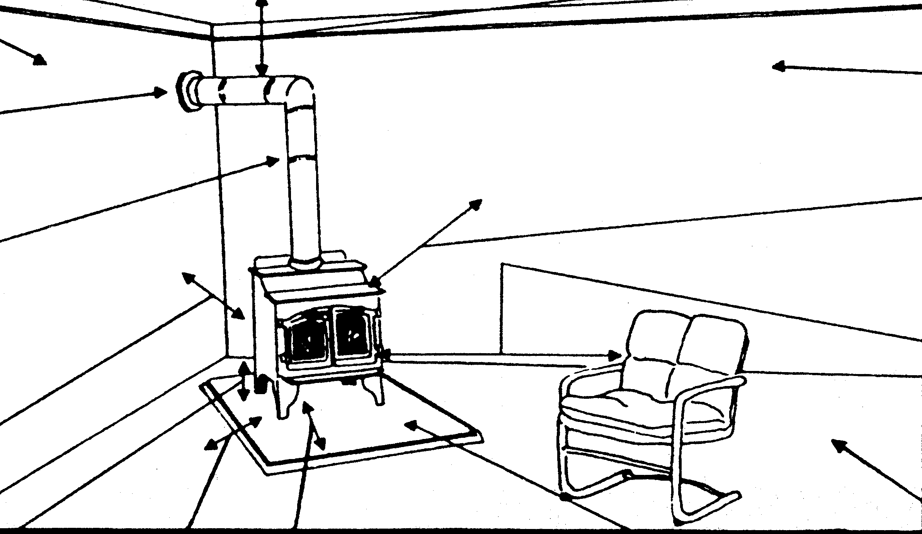  (a)  (c)  (d)  (e)  (f)  (g)  (h)  (i)  (k)  (m)  (n)  (p)  Distance from loading door to end of pad (i)  ____ in cm |  |  |  | Shortest distance of stovepipe to ceiling (p) in cm  Shortest distance from stovepipe to wall (n)  in cm  Construction of nearest side wall  Shortest distance of unit to nearest side  wall (m) in cm  Shortest distance of unit to furniture, fuel  or other combustible material (k)  in cm  Construction material of floor  Is there a non-combustible pad No Yes  Describe construction and thickness of base
1. Is the unit located at least 36”/92 cm from all walls? No Yes
2. Is stovepipe located at least 18”/46 cm from wall or ceiling? No Yes
If answer to 1. or 2. is “No”, state manufacturer’s installation requirements or describe protective shielding used.
3. If there are heat shields are they spaced 1”/25 mm from the wall or ceiling using
non-combustible spacers? No Yes N/A
Installation and Construction Legend
(a) Construction material of back wall  (b) Construction material of ceiling  (c) Pipe thimble  (d) Vertical length of stovepipe  (e) Shortest distance of unit to back wall |  | (f) Distance or clearance of unit to floor  (g) Shortest distance from side of unit to end of stove pad  (h) Distance from front of unit to end of stove pad  (i) Distance of loading doors to end of stove pad |  | (k) Shortest distance to furniture, fuel or combustibles  (m) Shortest distance to nearest side wall  (n) Shortest distance from vertical stovepipe to any wall  (p) Distance of horizontal stovepipe to ceiling
Remarks:
I have provided personal information in this document and by other means and I may in the future provide further personal information. Some of this personal information may include, but is not limited to, my credit information and claims history. I authorize my broker or insurance company to collect, use and disclose any of this personal information, subject to the law and to my broker’s or insurance company’s policy regarding personal information, for the purposes of communicating with me, assessing my application for insurance and underwriting my policies, renewals, changes of coverage, evaluating claims, detecting and preventing fraud, and analyzing business results. I confirm that all individuals whose personal information is contained in this document have authorized that I agree to the above on their behalf.
Completed by: |  |  | Date (yyyy/mm/dd):

